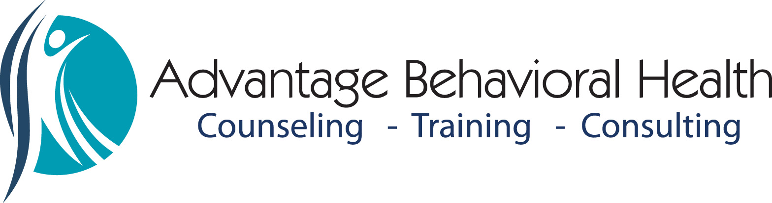Empowering Leadership Series
“If your actions inspire others to dream more, learn more, do more, and become more, you are a leader”-John Quincy Adams
Back by popular demand! The series is carefully designed to start with basic leadership skills and self-evaluation that build on one another through experiential and practice-based learning. Participants will gain valuable knowledge and skills to take their leadership success to the next level. Concepts are based on leadership principles by Jim Collins “Good to Great”.
Level 1: “What is leadership?” Learn the principles of the “bus”. Where are my skills and areas for growth?
DATE: Friday, February 10, 2017, 8:30-10:30am
Level 2: “Get on the Bus”. Leaders must drive their bus forward. Do you have the right people on your bus to reach your destination? Are you prepared to manage the unruly passenger?
DATE: Friday, March 10, 2017, 8:30-10:30am
Level 3: “Achieving successful navigation”. Great leadership ingredients; striving for Level 5 Leadership.
DATE: Wednesday, March 29, 2017 8:30-10:30am
Level 4: “Creating a culture of discipline”. Complex workplace issues and challenges integrated with disciplinary best practices.
DATE: Friday, April 21, 2017, 8:30-10:30am
Empowering Leadership Registration
Name_____________________________________________
Company__________________________________________
Address___________________________________________
Phone______________________ Email_________________
__Level 1 ($40 per person)__Level 2 ($40 per person)
__Level 3 ($40 per person)__Level 4 ($40 per person)
__Register me for all 4 workshops in advance. ($135 total)
__I wish to register for 2 of the 4 workshops. ($75 per person)
**Group discounts available for registering 5 or more participants at once. ($125 per person).
__Check __Credit Card __Purchase Order submitted __Visa __ Mastercard
Card #___________________________Expiration Date_____________ CV Code:_______
Please make checks payable to Advantage Behavioral Health. Questions, please contact Michelle Durpetti at (847)658-4224 or email mdurpetti@advantagebh.com.
LOCATION OF WORKSHOPS: Home State Bank, Lower level Community Room, 611 Main Street, Crystal Lake, IL 60014.
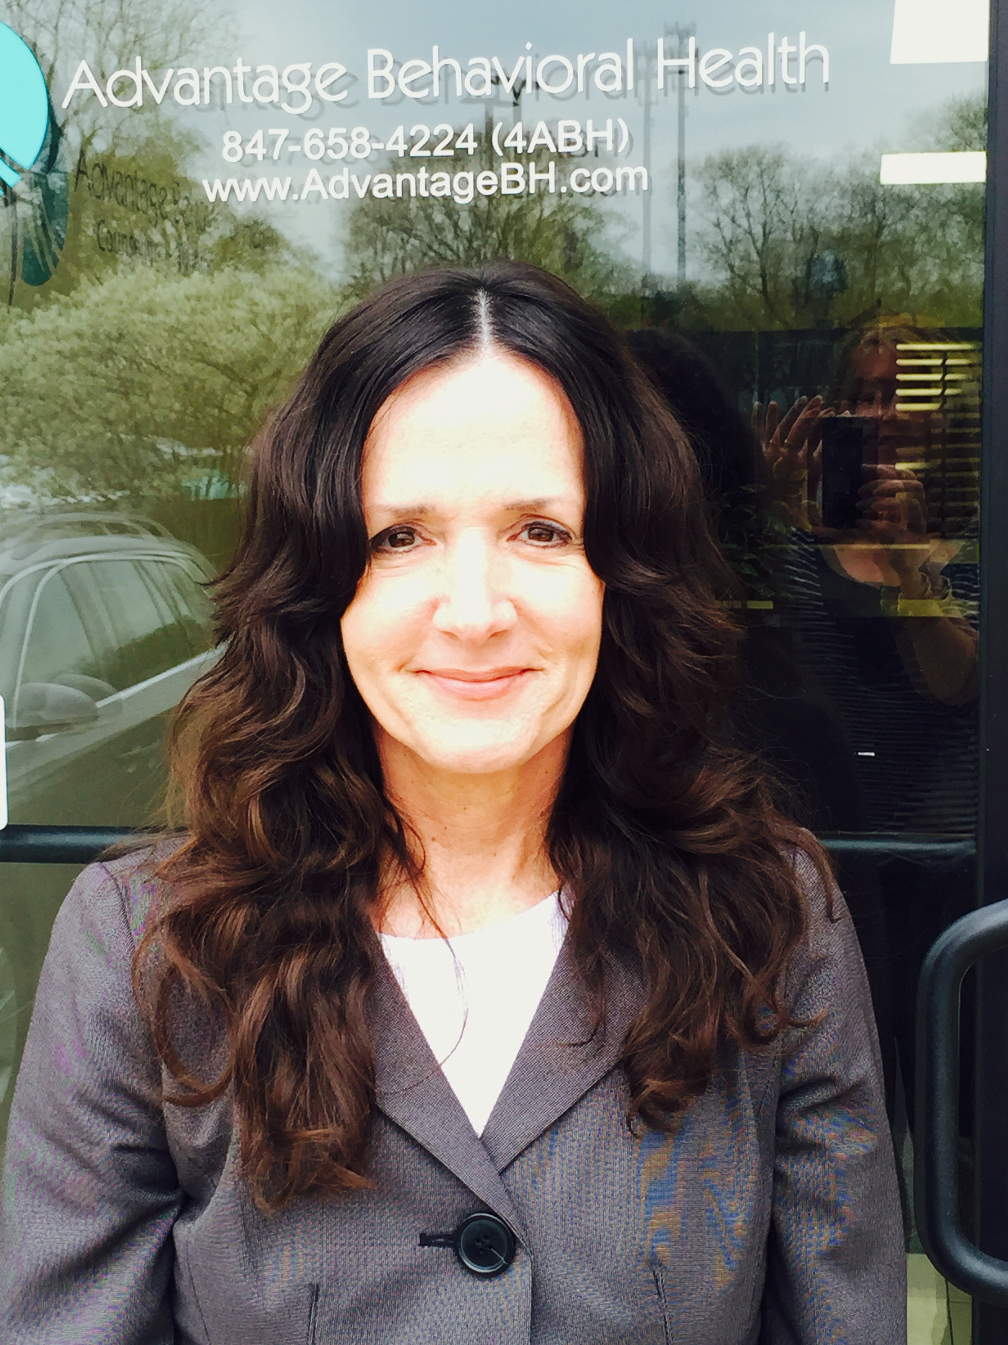
About the trainer: Melissa Forte, LPC, NCC, Type 73, has been as a working as a counselor both at the high school and collegiate levels for almost 9 years. She has a Master of School Counseling and Guidance degree from Lewis University and a Bachelor of Psychology degree with a minor in Sociology from Western Illinois University. Prior to that, Melissa worked in the corporate environment for 15 years as a trainer and supervisor in both the profit and non-profit sectors and has also taught as an adjunct instructor at the college level. Melissa’s specialties include working with youth and adults in the areas of life transitions, anxiety and depression, stress management, eating disorders, leadership skills, and mental toughness. She leads various workshops on college and career experience, time and organizational management, choosing and major/career, personality traits in the workplace, and resume building/interviewing skills.

